D.Y.PATIL COLLEGE OF ENGINEERING &TECHNOLOGY, KASABA BAWADA, KOLHAPUR
DEPARTMENT OF COMPUTER SCIENCE & ENGINEERING

(Academic Year: 2025-26)

Report

Of
Scripting Concepts Titled
“Quiz Application”

Submitted By:
Roll no. | Name
114 | Bhumi Baswar
115 | Shraddha Talekar

Under the Guidance of: Mrs. Ketaki Bhosale

Class: TY Div.:B Batch: T5

CERTIFICATE

This is to certify that following students

Roll no. | Name
114 | Bhumi Baswar
115 | Shraddha Talekar

have successfully completed the term work for entitled Quiz Application, towards the partial fulfillment of T.Y. (CSE) Sem VI during the academic year 2025-26.

Guide HOD Principal

ACKNOWLEDGEMENT

I express my sincere thanks to Mrs. Ketaki Bhosale

Computer Science and engineering Department whose supervision, inspiration and valuable guidance helped me a lot to complete my Scripting Concepts mini Project. Her guidance proved to be the most valuable to overcome all the hurdles in the fulfillment of this Project-III Report.
I also express my sincere thanks to Dr. R.J.Dhanal, Head of computer science department and Dr. Prof. S. D. Chede, Principal of D.Y. Patil College of Engineering & Technology Kolhapur. Last but not least, this acknowledgement would be incomplete without rendering my sincere gratitude to all those who have helped me in the completion of Scripting Concepts mini Project. Finally, I express my deep sense of gratitude to my parents & family members, who are the chief source of my inspiration.

Sincerely,

Bhumi Baswar

- Shraddha Talekar

INDEX

Chapter-1: INRODUCTION

1.1 Introduction

Chapter-2: PROBLEM STATEMENT

  - Problem Statement

  - Objectives

Chapter-3: DESIGN DETAILS

  - System Architecture Chapter-4: IMPLEMENTATION Chapter-4: CONCLUSION
  - Conclusion

  - Future Scope

Chapter -5: REFERENCES

5.1 References

Chapter-1: INRODUCTION\
  - Introduction
A Quiz Application is an interactive web-based system designed to test users’ knowledge in an engaging and efficient way. This project is developed using HTML, CSS, and JavaScript, providing a simple yet dynamic platform for users to participate in quizzes.The application allows users to select different categories such as Technology, General Knowledge, and Movies, making it versatile and interesting. Each quiz contains multiple-choice questions with a timer, which adds a challenge and improves user focus and time management skills. The system dynamically loads questions, checks answers instantly, and calculates the final score. User login history also saved in file .It also includes a detailed answer review feature, where users can see which answers are correct, incorrect, or not attempted. This helps users understand their mistakes and improve their knowledge.
The application follows a client-side architecture, where all processing is done in the browser using JavaScript. This makes the system fast, lightweight, and easy to use without requiring any backend server. Overall, the Quiz Application provides an effective and user- friendly way to conduct quizzes while enhancing learning through interactive features.

Chapter-2: PROBLEM STATEMENT

  - Problem Statement

Traditional quiz methods are often static, less interactive, and do not provide instant feedback or performance analysis. There is a need for a system that:
    - Provides real-time interaction

    - Includes time constraints

    - Shows correct and incorrect answers

    - Engages users with a modern UI

  - Objectives
    - To design an interactive quiz system with multiple categories
    - To implement a timer-based question mechanism
    - To provide instant feedback and score calculation
    - To track and display correct and incorrect answers
    - To enhance user experience using modern UI design
    - Saves the users details in file.

Chapter-3: DESIGN DETAILS

3.1 System Architecture

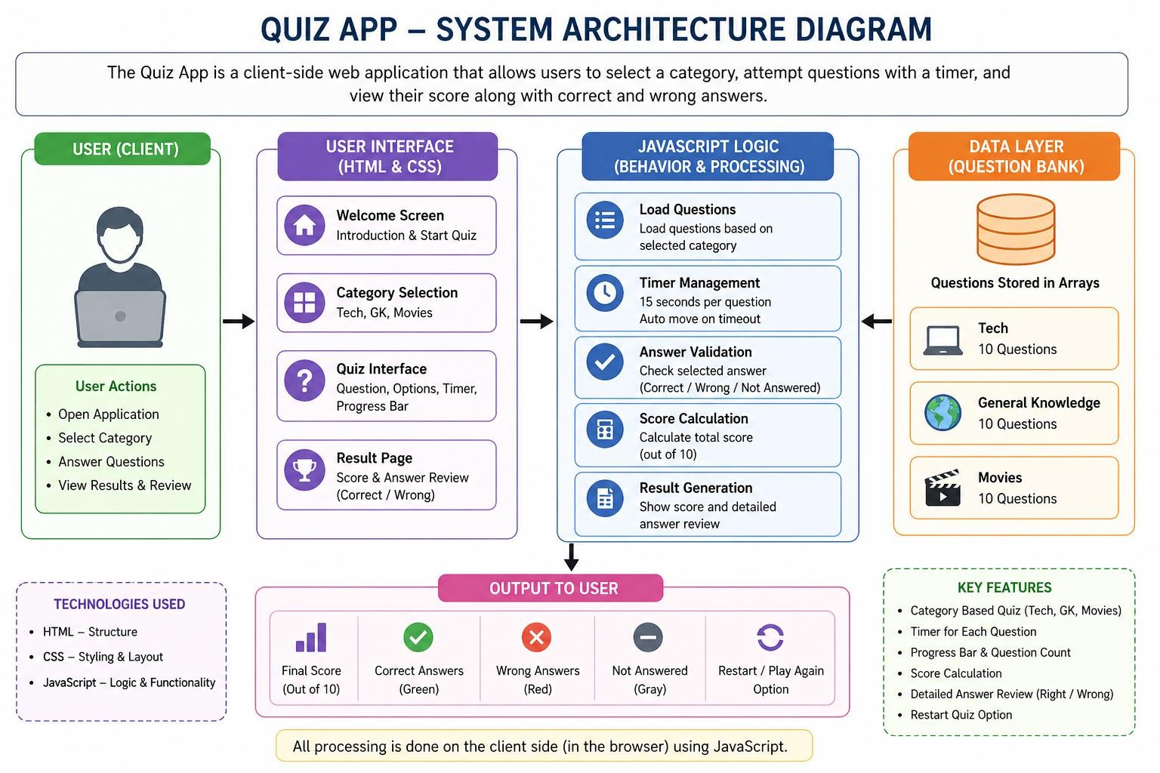

Chapter-4: IMPLEMENTATION
The Quiz Application is implemented using three main technologies:

Frontend (HTML & CSS)
  - HTML is used to structure the application into different sections like welcome screen, category selection, quiz interface, and result display.
  - CSS is used to design a modern and responsive user interface with styling, colors, and layout.

JavaScript (Core Logic)
  - JavaScript handles the dynamic behavior of the application.
  - Questions are stored in arrays based on categories.
  - Timer functionality is implemented using setInterval().
  - User answers are stored and evaluated.
  - Score calculation and result display are dynamically generated.

Features Implemented
  - Category-based quiz system
  - Timer for each question
  - Progress tracking
  - Answer validation (correct/wrong)
  - Final result with detailed analysis
  - Saves history of users in file

Chapter-4: CONCLUSION

  - Conclusion

The Quiz Application successfully demonstrates the use of web technologies to create an interactive and user-friendly system. It provides an efficient way to test knowledge with immediate feedback and performance analysis.The project enhances user engagement through features like category selection, timer-based questions, and answer review. It can be further extended by integrating databases, adding user authentication, and implementing leaderboards

  - Future Scope
The Quiz Application can be further enhanced by adding several advanced features to improve functionality and user experience. In the future, the system can be integrated with a backend database such as MySQL or Firebase to store questions dynamically instead of using static arrays. This will allow easy updates and management of quiz content.
A leaderboard system can be implemented to display top scores, making the application more competitive and engaging.
The application can be extended to include difficulty levels such as easy, medium, and hard, as well as randomized questions to ensure a unique experience for every attempt. Additionally, incorporating multimedia elements like images, audio, and video in questions can make the quiz more interactive.
.

Chapter -5: REFERENCES

  - References
    - Mozilla Developer Network (MDN) – JavaScript, HTML, CSS documentation
    - W3Schools – Web development tutorials
    - Visual Studio Code – Code editor used for development
    - JavaScript documentation (ECMAScript standards)

